M20 4G Dual Cam MDVR
User
Manual

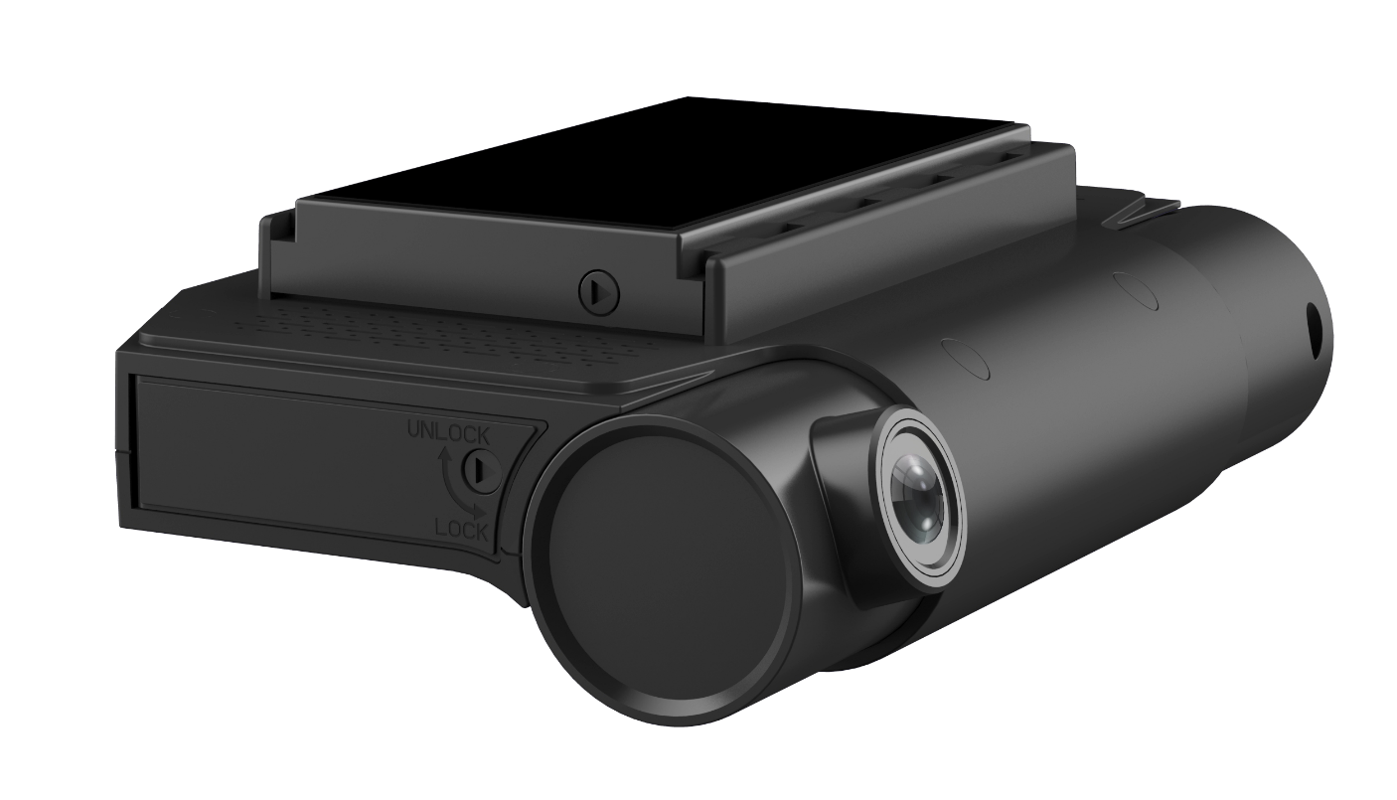

Contents

1. Features & Models 2
2. Specification 3
3. LED Light Indication 5
4. Outlook and Indication: 5
5. Mobile APP Configuration 6
6. Wiring Diagram Office Testing Diagram 10
7. 4ch M20 Connect 12V CAM3, CAM4 Diagram 11

Features & Models
Features | Standard Version | Premium Version
H.265 High Efficient Video Recording & Compression | ✓ | ✓
1080P Full HD 2* Embedded Wide Angle Camera (support max 4*CH） | ✓ | ✓
4G Remote Live Streaming/Downloading (Compatible with 3G) | ✓ | ✓
Alarm Video Upload to Cloud Server Storage Automatically | ✓ | ✓
Sleeping Mode for 7*24 hours Surveillance | ✓ | ✓
Driver Face Recognition & Local Identification (Update via FTP) | ✓ | ✓
Built-in Independent 4G LTE, Wi-Fi Antenna & Modem | ✓ | ✓
Built-in High Performance GPS/GLONASS Antenna & Modem | ✓ | ✓
Configurable GEO-fence zone in Dashcam with Alarm Output Control | ✓ | ✓
Built-in Microphone & Speaker for Two Way Communication | ✓ | ✓
Wi-Fi AP/Client mode for Configuration & Automatic Upload | ✓ | ✓
SOS Panic Button Alarm (Embedded) | ✓ | ✓
2* I/O Alarm Input | ✓ | ✓
1* I/O Alarm Output for Immobilization/Cut off fuel | ✓ | ✓
Harsh Braking/Acceleration/Cornering/Collison  Alarm(Configurable G-value, Automatic Calibration with TFT monitor) | ✓ | ✓
Alarm Pre-Recording, Post-Recording | ✓ | ✓
Built-in Super Capacitor UPS Data Protection  (4 seconds after Shut Down) | ✓ | ✓
Dual Micro SD Card Recording (support max 2*512GB) | ✓ | ✓
SD& Sim Card Tamper-proof Lock | ✓ | ✓
1* CVBS Video Output | ✓ | ✓
Support CMSV6, Gurtam Wialon, Curbsoft, GPS-server,GPSwox, Key Telematics | ✓ | ✓
RS232 Interface for Ultrasonic Fuel Level Senor/RFID/Temperature Sensor | x | ✓
1080P 12V Camera 3 Input Interface | x | ✓
1080P 12V Camera 4 Input Interface | x | ✓

Specification
Item |  | Description
 |  | 2CH M20: Standard Version
 |  | 4CH M20: Premium Version
OS |  | Linux3.18
Operating |  | IOS/Android APP, PC Client, WEB/Gurtam Wialon
CPU |  | HI3520D V400
Processor core |  | ARM Cortex A7 dual core @max.1.3GHz
RAM |  | DDR3 512MB
Video and  Preview | Video Input | DCAM005: 2Channel 1080P AHD built-in  DCAM006: 2Channel 1080P AHD built-in, External 2CH 1080P AHD
 | Dual Camera Lens | Front Road View: 130 Degrees, 2.1mm Lens, 30fps.  In Cab View: 120 Degrees, 2.5mm Lens, 30fps
 | Video Output | 1x CVBS (DCAM006 Only)
 | Face Identification | Supports face recognition comparison function  (Option, Not supported by default)
 | OSD | Time and date, device ID and GPS, Alarm, etc.
 | Video Compression  Format | H.265/H.264
 | Live Streaming | 2Channel at same time, Max 4Chnnall at same time
 | Image quality | Level 1 to 3 Configurable
 | Preview function | IOS/Android APP/PC Client/WEB Brower preview (Flash Player or HTML5)
 | Resolution | AHD: 1080P 60fps, 720P: 120fps
Audio | Audio Input, Output | 1 built-in MIC, 1 External Microphone (intercom, recording)  1 built-in speaker (intercom, voice prompt)
 | Compression Format | G.711A, G.726
Recording Video mode | Storage Medium | 2x Micro SD Card Slot, max 2x512GB
 | Video mode | - Support Dual SD card loop recording (the earliest recording is deleted).  - Support Mirror Recording  - Alarm Recording: Pre/Post-recording, Upload to Server Automatically  - ACC Recording, Manual Recording, Timing Recording  - ACC Delay Recording to enter Sleeping Mode
 | History Footage | - Support SD card history footage review/download by PC Client, Android APP, Gurtam Wialon  - Support Cloud Server saving Alarm/Normall videos footage
 | File format | H.265/FAT32, Encrypted
 | Video playback | Android, PC Client, WEB, Gurtam Wialon
Network | 4G/5G | - Built-in 4G Module & 4G Antenna, compatible with 3G/4G/5G  - Selectable Quectel EC25-EC/-AU/-AF/-J/-EU… 4G Modules  - Support EVDO/TD-SCDMA/WCDMA/TDD-LTE/FDD-LTE ect.
 | WiFi | - Built-in Wi-Fi Module & Antenna, 802.11b/g/n,2.4G/5.8G optional.  - Configurable WiFi SSID and Password  - Switchable WiFi AP & Client Mode  - Support WiFi Uploading automatically when in Wi-Fi Hot Spot
 | GPS/GNSS | - Built-in High Performance and Accuracy GPS Module &Antenna  - Modem: Ublox  - Position System: GPS,GLONASS,BeiDou, Galileo  - Frequency: 1575.42 Mhz (GPS,BeiDou,Galireo), 1602 Mhz(Glonass)  - Cold Start: <30s, Hot Start: 1~3s  - Configurable 8 Rectangle Geo-fence Zone in Dashcam with Alarm Output Controld
Power Supply and Power Consumption | Ignition/ACC | ≤6V,ACC OFF. ≥7.5V,ACC ON.
 | Input Voltage | DC:+8V ~ +36V. If the voltage is lower than 8V or higher than 36V for a long time,the device will automatically shut down and enter the protection mode.
 | Output Voltage | 5V Camera x 2. Or 12V Power Adapter for 2* 12V Camera
 | Built-in UPS  (Super Capacitor) | - 2x7F*2.7V Super Capacitor.  - Charging Full: 2 minutes  - Sudden Power Off Data Recording Maintenance: 4S
 | Power Consumption | - Active Mode: 7W, 0.6A @12V DC  - Sleeping Mode: 0.2W,0.02A @ 12V DC
Interfaces | Serial Port | 1x RS232, Compatible with:  RFID Reader, Ultrasonic Fuel Level Sensor, Temperature Sensor
 | Digital Inputs | 2x IO High/Low Input , Threshold: 4V DC
 | Digital Output | 1x IO Output for Immobilizer /Cut off Fuel
 | SOS Panic Button | 1x SOS Panic Button Embedded in Dashcam
Alarm | Alarm Recording | Pre-Recording:  Post-Recording:
 | Digital I/O Alarm | - ACC/Ignition on/off Alarm  - 2x I/O Alarms Input for Door Open/Close, Left/Right Turn, Braking
 | SOS Alarm | 1x SOS Emergency Alarm
 | Harsh Alarm | Harsh Braking, Acceleration, Cornering, Collision Alarm
 | Fuel Theft Alarm | - Must work with Ultrasonic Fuel Sensor UL212 to realize  - Fuel Theft Alarm → Trigger Dashcam Power On from Sleeping Mode →Recording Alarm Video and Upload to Server Automatically
Platform | Video Streaming  +GPS Tracking | CMSV6, Gurtam Wialon, CurbSoft
 | GPS Tracking | CMSV6, Gurtam Wialon, Curbsoft  GPS-server, GPSwox, Fueltelematics.com, Key Telematics
Operating  Environment | Temperature | preheating: 20℃ ~ +70℃
 | Humidity | 8% to 90%
Size |  | 126(L)x 81.5(W) x 41(H) mm.
Weight |  | NW: 0.3KG  G.W.: 0.65G

LED Light Indication
Indication | Description
GPS | Quick Flash: Search GPS  Stay On: GPS Located Successfully
REC | Stay On: Recording  Stay Off: Not Recording or Micro SD Card lost
4G | Stay On: 4G Modem is working, and Dialing Up  Quick Flash: Connected Successfully to Server
WiFi | Stay On: WiFi AP is working  Quick Flash: Data Transferring

Outlook and Indication:

Front View

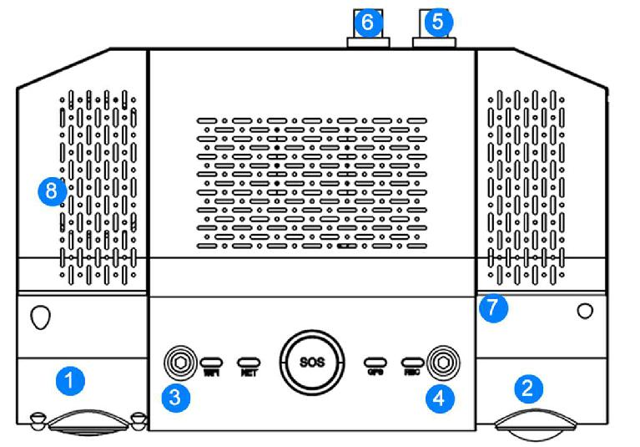

Indication | Description
WiFI | WiFi Status
NET | 4G Network connection Status
SOS | Panic Emergency Button
GPS | GPS Status
REC | Recording Status
1 | In Cab Camera (Left Drive), Road View Camera(Right Drive)
2 | Road View Camera(Left Drive),In Cab Camera (Right Drive),
3,4 | Screws to fasten Camera
5 | Power + IO Harness
6 | Camera 3, 4 input (DCAM006 Only)
7 | Built-in Microphone
8 | Built-in Speaker

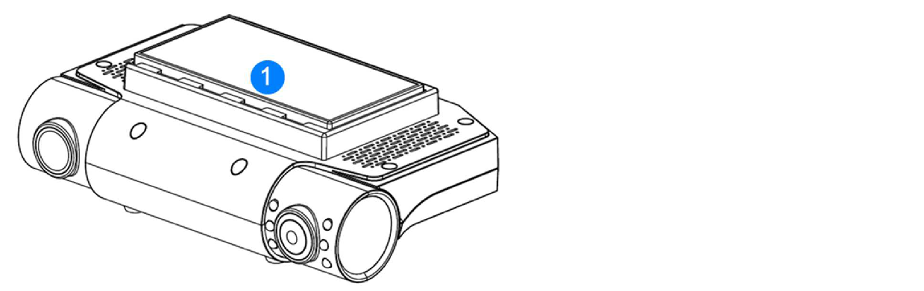

Indication | Description
1 | 3M Adhesive Sticker

Mobile APP Configuration

  - Download CMSV7 or CMSV6 from Android Google Play or IOS APP Store

2) Disable Cellular Data:
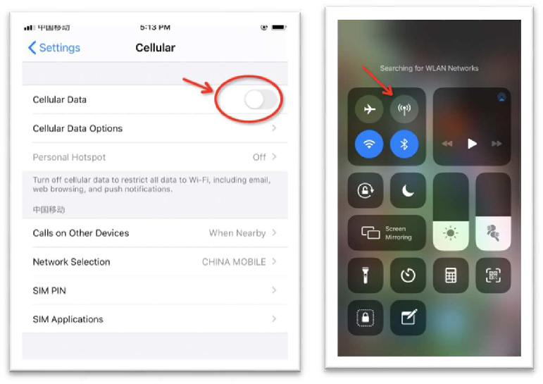

3) Power On Dashcam, and search WiFi SSID MDVRxxxxx, with password 99999999 to connect

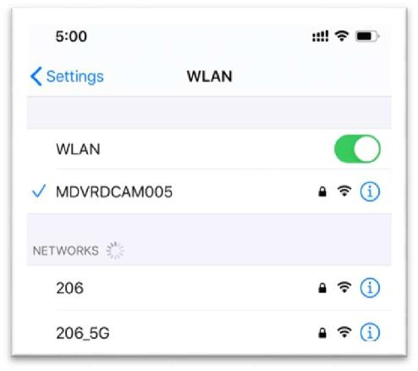
4) Open CMSV7 and Click Find (NO LOGIN now)
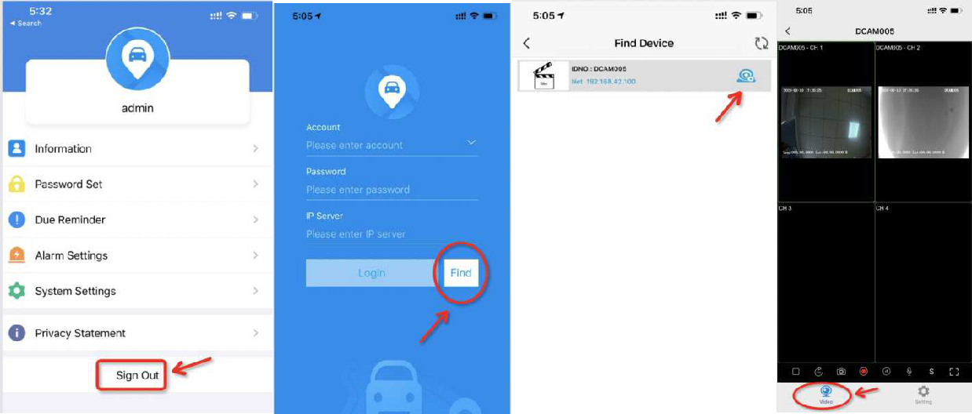

5) Enter Setting and Configure IP, Port, Device ID, 4G APN, etc.

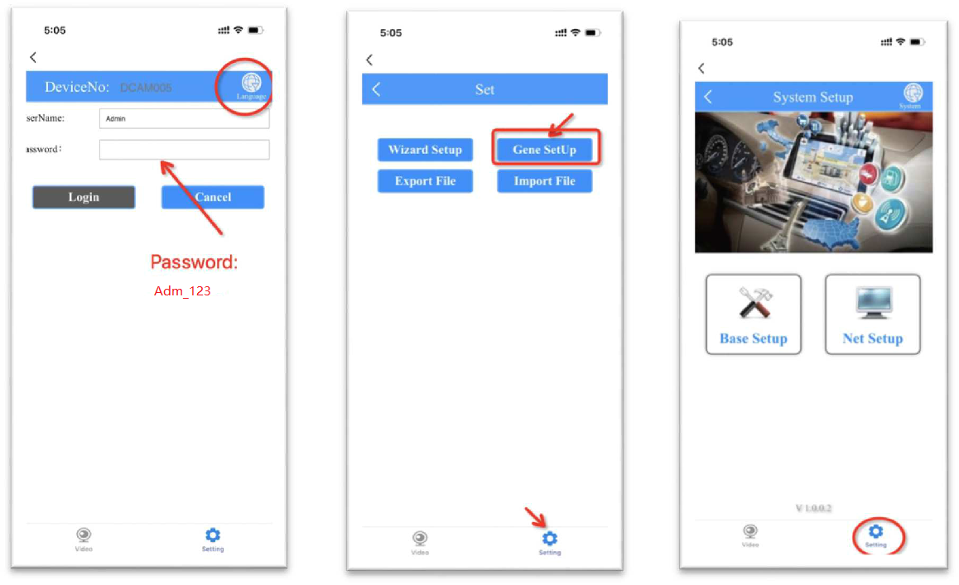

6) Configure Device ID Number for CMSV6/ Wialon, and Mirror Setting
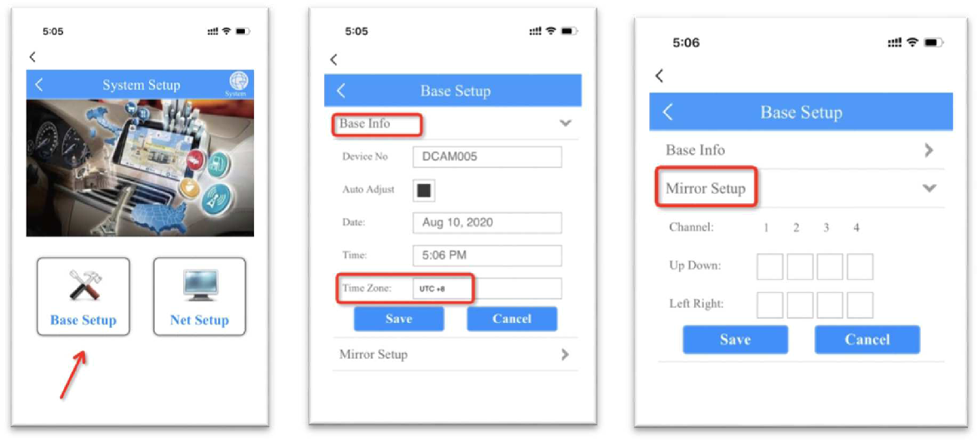

7) Configure CMSV6 Server IP, Port
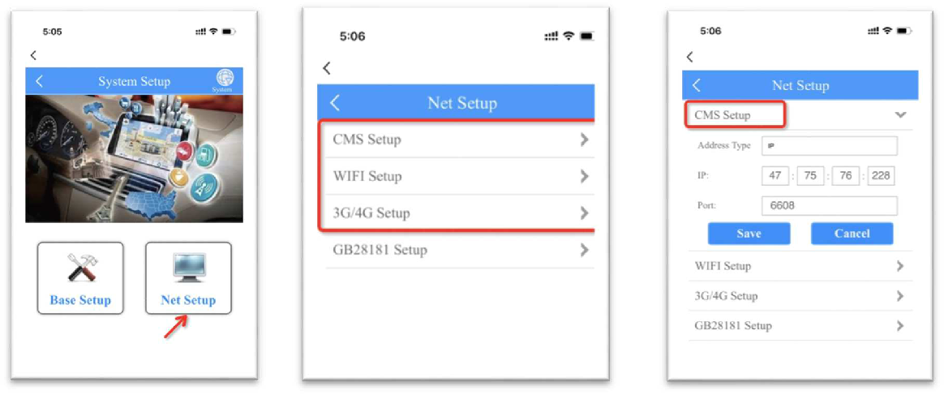

8) Configure 4G Sim card APN (keep *99# as fixed setting, without change )

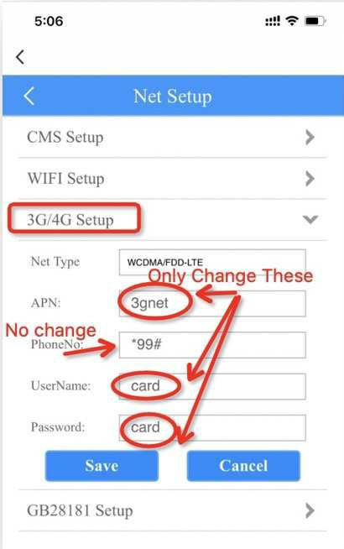

  - Change WiFi AP, Client Setting

- AP Mode: Mobile Phone can search and connect

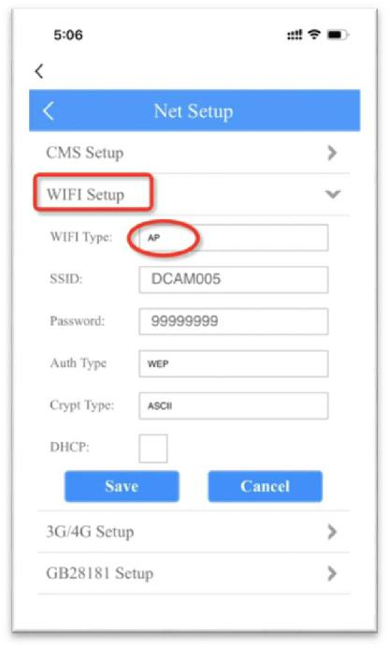

- Client Mode: Connect Dashcam to Office WiFi Hot Spot

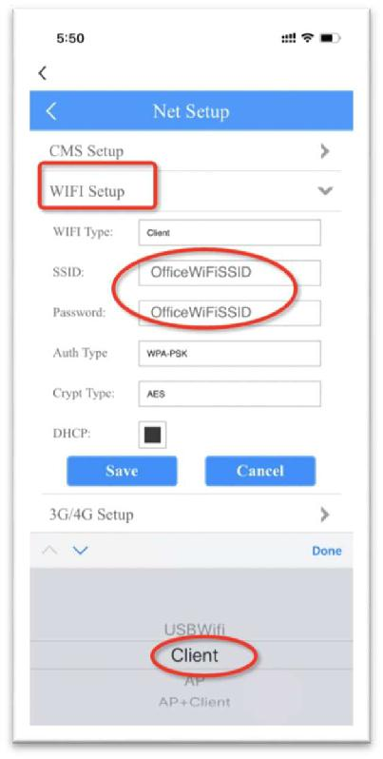

Wiring Diagram Office Testing Diagram
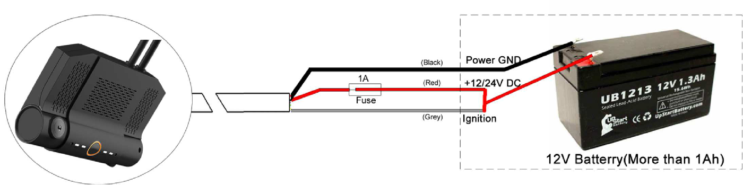

Outdoor In Car Diagram——Recommended
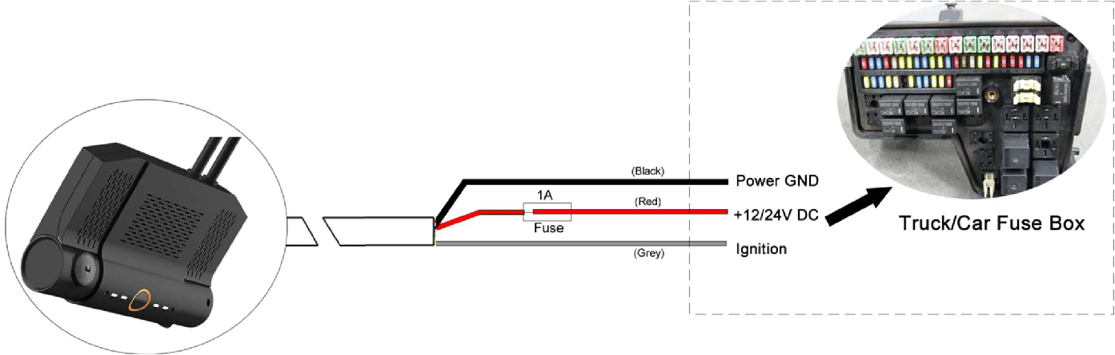

Outdoor In Car Diagram——Optional for LCV Vehicle
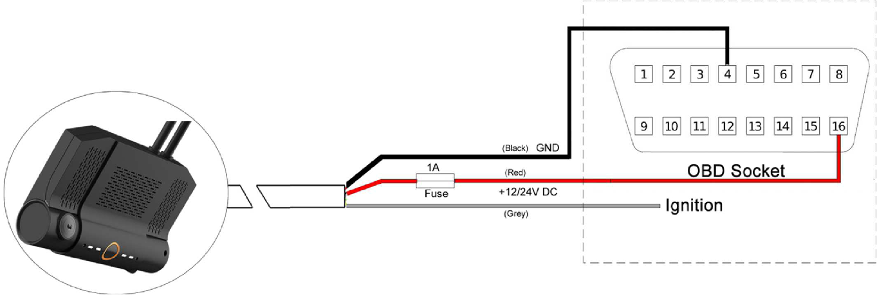

4ch M20 Connect 12V CAM3, CAM4 Diagram
